Research Contracts & Innovation
For Office Use
No.
Date Received:
Date Evaluated:
Decision:
Initiated:
Applicant informed
Pre-Seed Fund

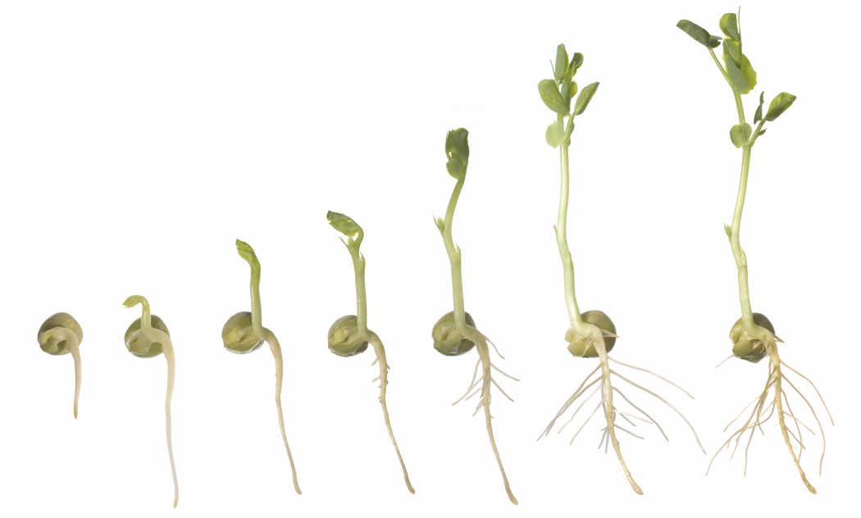
Concept
Funding Application Form

Project Title | Insert a short title that can be used for easy reference
Applicant (Project Leader) Details
Title, Name, Surname
Email address
Staff / Student*?
Phone no.
Department
Team Members
How has project been funded to date?
Is the IP wholly UCT owned? If not, provide details.

*If student, then include details of your Supervisor as the research fund if awarded will be registered in their name.

The blue text below is a guide for proposal completion and should be deleted prior to submission. Email your completed form to Mpho Baisitse at mpho.baisitse@uct.ac.za call 021 650 4976 if you have queries.

1. Product or Service Overview

Briefly describe the product or service that is under development and how it will be marketed. What is the specific technology innovation (product/process/service) that either has been or is planned to be developed? How does the above mentioned innovation differ from current technology offerings in the same field? What is the end product or end result of this project?

What is its market potential? What is the longer-term plan should the product or service be commercialised, e.g. spin-off, start-up, license technology. Have relevant potential industrial partners and/or investors been identified? Have you already initiated discussions with external parties?

Has IP already been protected by RC&I? Is additional IP protection required? If so, please detail this.

2. Project Motivation

Describe the specific project that will be undertaken using the Concept Funding and motivate its significance, i.e. why funding should be granted. How will it improve the commercial potential of the project or bring the invention closer to market?

Also indicate what the next step will be on completion of the Concept project.

3. Project Activities and Key Tasks

List and describe the key tasks (milestones) that will be undertaken in the Concept- funded project in the table below. Include a date by which you expect to have completed the task.

No. | Task Title | Task Description | Task Duration | Expected Completion Date | Deliverable
1
2

3.1 Human Resource Requirements

Detail the Human Resource Requirements - ideally identify them by name. Identify non-UCT service providers/consultants.

3.2 Resource Availability

Will the Concept project commence immediately on award of funds (i.e. are human and equipment resources available immediately)? Note any possible project constraints.

4. Outcomes

List the key outcomes expected from your project. This should be defined in as measurable a manner as possible and related to the Key Tasks listed in Section 2.

5. Budget (Excluding VAT)

Provide a detailed breakdown of your budget, listing key items associated with each task in the table below. Attach quotations to this proposal where appropriate. If possible provide detail of competitor quotations and reason for selecting the quotation included in the project budget.

Task No. | Item | Amount  Labour  (R) | Amount Materials  (R)
TOTAL (excluding VAT)

TOTAL PROJECT BUDGET (excl VAT) | R

6. Project Planning

- Using a Gantt Chart, please indicate the timeline of the project by showing the activities - as stated in section 2. Please indicate Milestones for the project on this Gantt Chart which will be used to monitor the progress.

- Submit a Drawdown Schedule indicating when in the project must funds be released and what criteria must be satisfied before funds are released. The milestones will be used as the measuring tool against the predetermined goals to determine project progress and the release of funds.

 | Start Date 1 April 20XX
 | Month 1 | Month 2 | Month 3 | Month 4 | Month 5 | Month 6 | Month 7 | Month 8
Activity 1
Activity 2
Activity 3
Milestone | SC Feedback |  |  | Prototype |  | Revised |  | Final Report

7. Project Assumptions

What assumptions are made in this project? What are the technical limitations of the project for example what facilities are required to do further testing? What is the furthest this project can be taken prior to engaging a commercial partner?

